Shakespeare Quote Generator
Abstract:

This project is about making a program that creates quotes in the style of Shakespeare when given a word. Using smart computer models, it helps users generate creative, poetic quotes based on their input. We made a computer program that combines a trained model with a user-friendly app to let anyone enjoy Shakespeare-like quotes.

Introduction
Shakespeare wrote many beautiful quotes, and his works are loved by people all over the world. In this project, we created a computer program that can write new quotes like Shakespeare’s. If someone enters a word, the program will use its training to create a special quote. This helps people enjoy creative quotes and have fun with words.

Literature Review
Other programs like chatbots and writing tools have been made to help with writing. Programs like GPT and similar models have been trained to write stories, poems, and answers. Our project is unique because it focuses on creating quotes that sound like Shakespeare’s writing, which is full of poetry and old-style English.

Methodology:

Experimental Setup
Tools Used:
Google Colab for training the model.
TensorFlow and Keras for building the quote generator.
Tkinter for making the user-friendly app.

Train the model using Shakespeare’s text.
Convert the trained model to work in our app.
Connect the model to the app so users can enter a word and see the generated quote.

Findings:
The trained model could create quotes that sound like Shakespeare’s writing.
Users enjoyed seeing creative quotes when they entered words like “love,” “dream,” or “time.”
The app was easy to use, and the quotes felt poetic and fun.

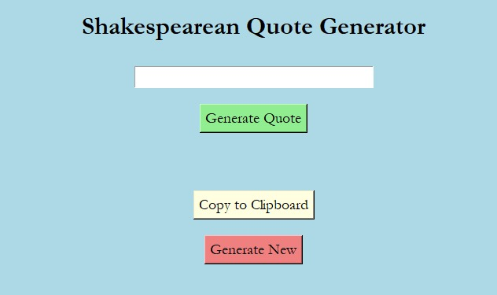

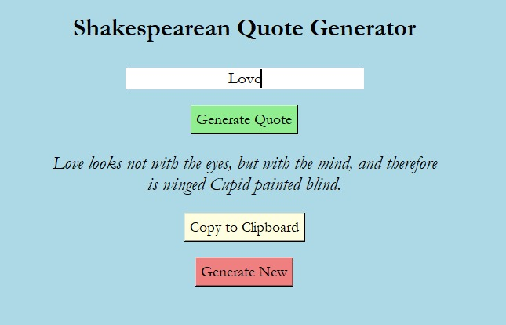

Discussion:

The project showed how computers can learn to write like Shakespeare. While the quotes were good, some could have been better. The model sometimes struggled with rare words or very complex sentences. But overall, the program worked well, and users enjoyed the experience.

Conclusion:

We successfully made a program that lets users create Shakespeare-like quotes. This project combined smart computer models with an easy-to-use app. It’s a fun way to explore language and creativity. In the future, we could improve the model and make it understand even more words and styles.

